Power Pages 1 Day

Power Platform WorkshopPLUS

Lab 4: Multistep Forms and Security

Conditions and Terms of Use

Microsoft Confidential - For Internal Use Only

This training package is proprietary and confidential and is intended only for uses described in the training materials. Content and software is provided to you under a Non-Disclosure Agreement and cannot be distributed. Copying or disclosing all or any portion of the content and/or software included in such packages is strictly prohibited.

The contents of this package are for informational and training purposes only and are provided "as is" without warranty of any kind, whether express or implied, including but not limited to the implied warranties of merchantability, fitness for a particular purpose, and non-infringement.

Training package content, including URLs and other Internet Web site references, is subject to change without notice. Because Microsoft must respond to changing market conditions, the content should not be interpreted to be a commitment on the part of Microsoft, and Microsoft cannot guarantee the accuracy of any information presented after the date of publication. Unless otherwise noted, the companies, organizations, products, domain names, e-mail addresses, logos, people, places, and events depicted herein are fictitious, and no association with any real company, organization, product, domain name, e-mail address, logo, person, place, or event is intended or should be inferred.

© 2021 Microsoft Corporation. All rights reserved.

Copyright and Trademarks

© 2021 Microsoft Corporation. All rights reserved.

Microsoft may have patents, patent applications, trademarks, copyrights, or other intellectual property rights covering subject matter in this document. Except as expressly provided in written license agreement from Microsoft, the furnishing of this document does not give you any license to these patents, trademarks, copyrights, or other intellectual property.

Complying with all applicable copyright laws is the responsibility of the user. Without limiting the rights under copyright, no part of this document may be reproduced, stored in or introduced into a retrieval system, or transmitted in any form or by any means (electronic, mechanical, photocopying, recording, or otherwise), or for any purpose, without the express written permission of Microsoft Corporation.

For more information, see Use of Microsoft Copyrighted Content at

<http://www.microsoft.com/about/legal/permissions/>

Internet Explorer, Microsoft, Microsoft Dynamics, Microsoft Dynamics logo, and Windows are either registered trademarks or trademarks of Microsoft Corporation in the United States and/or other countries. Other Microsoft products mentioned herein may be either registered trademarks or trademarks of Microsoft Corporation in the United States and/or other countries. All other trademarks are property of their respective owners.

Table of Contents

Lab 4: Multistep Forms and Security 5

Part 1: Getting Started 6

Part 2: Multistep Forms and Steps 8

Part 3: Connecting the Steps 15

Part 4: Application Web Page 17

Part 5: Page Permissions 19

Part 6: Table Permissions 21

Part 7: Testing Your Form 24

# Lab 4: Multistep Forms and Security

Introduction

During this lab, you will be adding a new form to the 311 Anytown site to allow visitors to apply for jobs in Anytown.

Objectives

After completing this, you will be able to:

* Create Multistep Forms
* Create Multistep Form Steps
* Connect Multistep Form Steps
* Implement secure page access

Prerequisites

* Completion of Lab 3

Estimated Time to Complete

* 45 minutes for the following steps

## Part 1: Getting Started

1. Navigate to make.powerapps.com, select the appropriate Dataverse environment—not default.
2. Under **Apps,** identify the **Anytown 311** model-driven app. This was installed as a part of the managed solution and is where Anytown’s employees would be able to see submitted tickets and other data submitted from the site. Click on its name to open it.

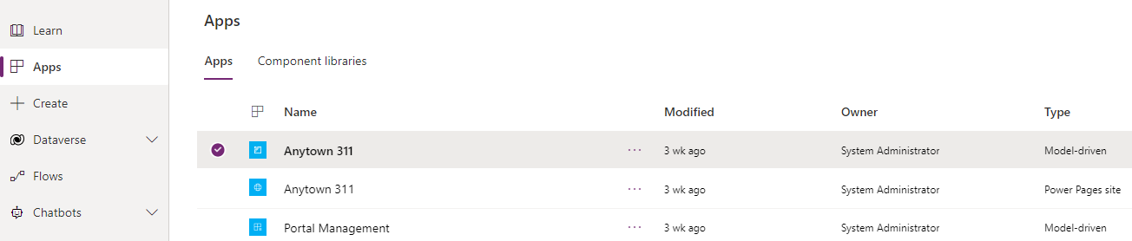

1. From the left navigation bar, select **Jobs.**
2. From the view, click on **+ New** to create a new Job record.

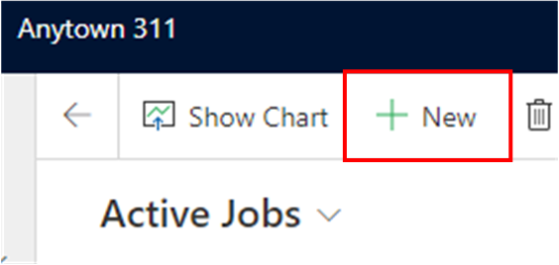

1. Populate the fields on the screen and click on **Save and Close**.
2. Repeat Steps 4 and 5 to create a couple of additional Job records.
3. From the navigation on the left, click on **Applications**.
4. From the ribbon, click + **New**.

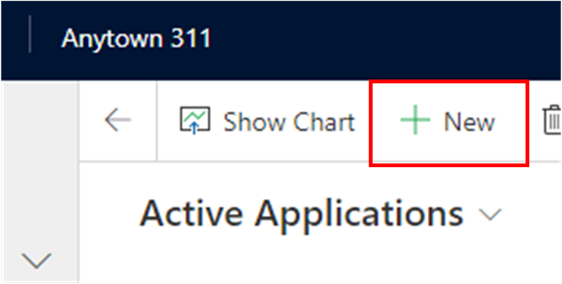

1. Observe the form and fields users will see. Toggle the form to the Portal form.
   * Note how the information has been split into tabs. These will be the steps of the multistep form.

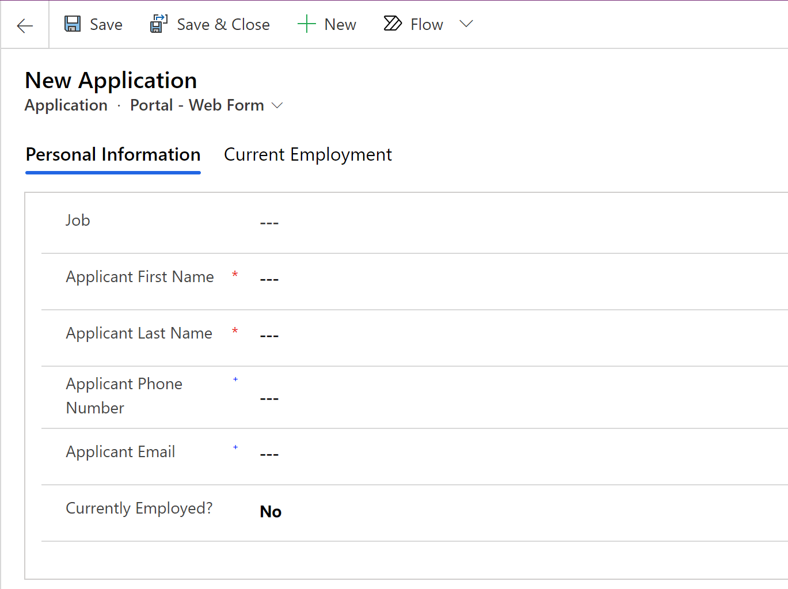

## Part 2: Multistep Forms and Steps

1. Navigate to <https://make.powerpages.microsoft.com>.
2. Click **+ Page** to add a new web page.

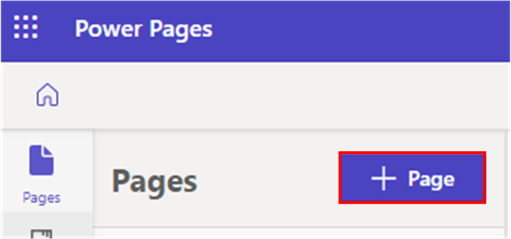

1. Name this page **“Apply Now”** and select the **Page** layout within the **Standard layouts** tab.

1. Click **Add**.
2. Select the bottom section and then select the ellipses **(…)** from the option bar. Click **Delete** to remove this section.

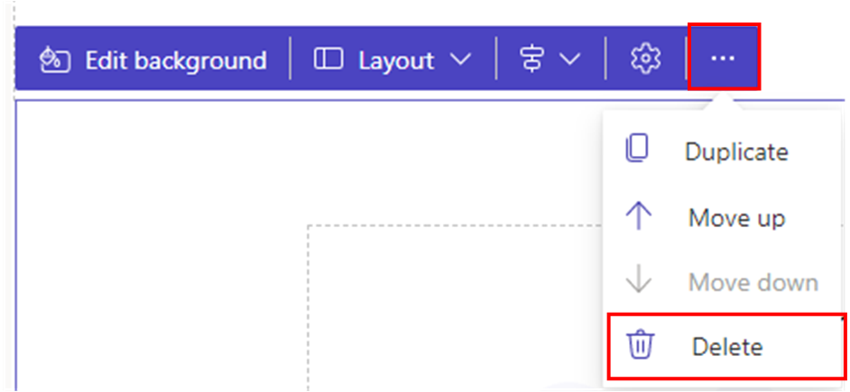

1. Click on the **+ ADD A SECTION** button below the top section and select **1 Column**.

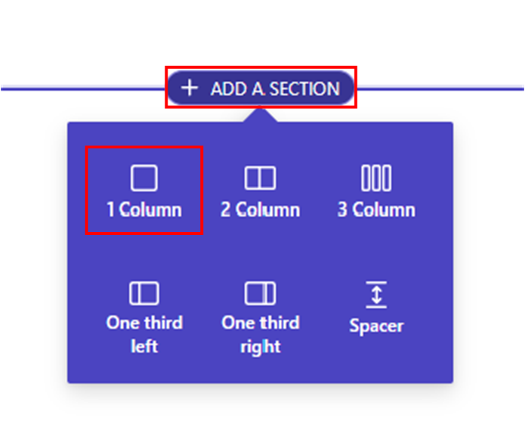

1. Select the **Multistep form** component within the newly added section.

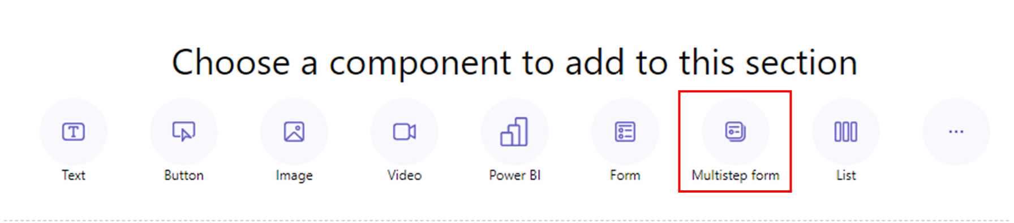

1. Set the form name to **Application** and click **OK**.

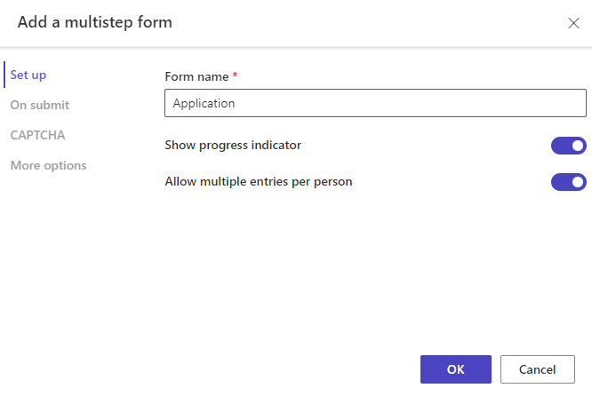

1. Steps for the multiselect form can be created from the Design studio and the Portal Management application. We will complete the rest of this exercise in Portal Management. Select the ellipses **(…)** and then **Portal Management** from the left navigation bar.

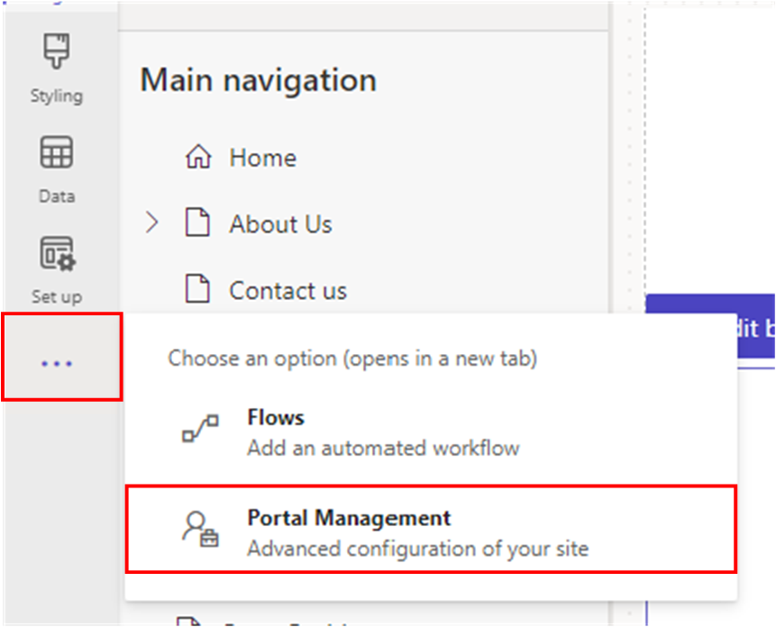

1. Navigate to **Multistep Forms** from the left navigation bar and open your newly created multistep form.



1. Navigate to the **Form Steps** tab.
2. Click **+ New Form Step**.



1. Enter the following information:
   1. Name: 01- Personal Information
   2. Multistep Form: Application
   3. Type: Load Tab
   4. Target Table name: ce_application (Application (ce_application))

1. Navigate to the **Form Definition** tab.
2. Enter the following information:
3. Mode: Insert
4. Form Name: Portal – Web Form
5. Tab Name: Personal Information (Contact)

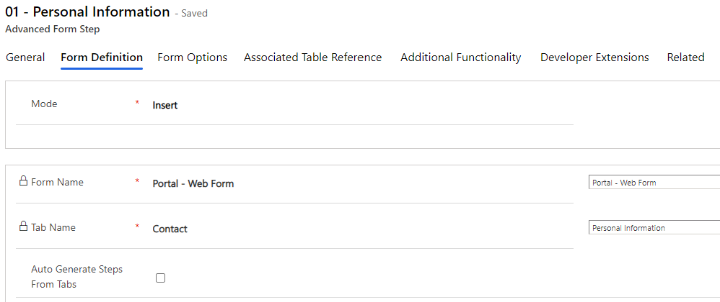

1. Click **Save & Close** on the ribbon bar.This will return you to the Multistep Form record, which contains the steps we are creating.

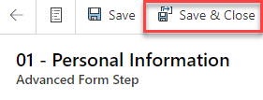

1. Back on the Application multistep form record, on the Form Steps tab click on **+ New Form Step** again.
2. Enter the following information:
3. Name: 02 – Condition
4. Multistep Form: Application
5. Type: Condition
6. Target Table name: ce_application (Application (ce_application)

1. Navigate to the **Condition** tab.
2. Enter the following information:
3. Condition: **ce_currentlyemployed==true**.
   * 1. This will evaluate that field for yes/no value that equates to yes**.**

1. Click **Save & Close** on the ribbon bar.
2. On the Form Steps tab click on **+ New Form Step**.
3. Enter the following information:
4. Name: 03 – Employment Information
5. Multistep Form: Application
6. Type: Load Tab
7. Target Table name: ce_application (Application (ce_application))

1. Navigate to the **Form Definition** tab.
2. Enter the following information:
3. Mode: Edit
4. Form Name: Portal – Web Form (Portal – Web Form)
5. Tab Name: Employment (Current Employment)
6. Source Type: Result From Previous Step

1. Click **Save & Close**. Back on the Multistep Form record, this is how your subgrid should look:

## Part 3: Connecting the Steps

Now that all steps have been created, we need to connect them.

1. From the Application Advanced Form, open the **01 - Personal Information** step.
2. Populate **Next Step** with **02 - Condition**.

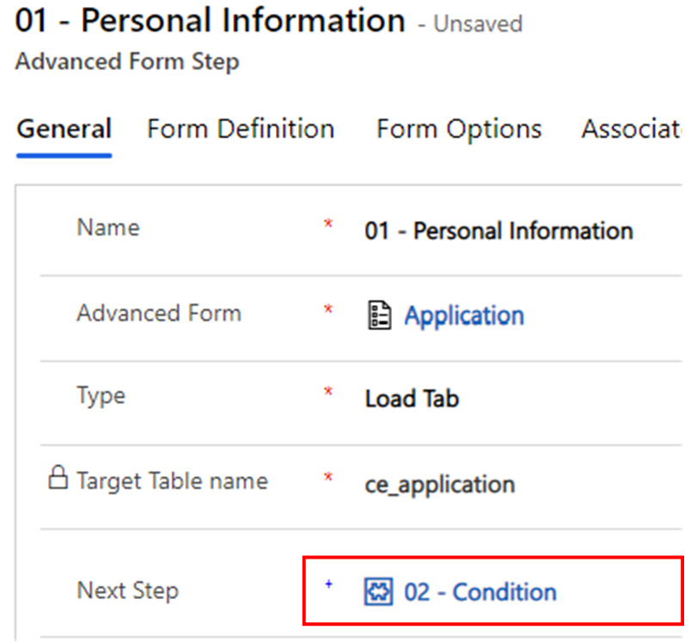

1. Click **Save &** **Close**.
2. Open the **02 - Condition** step.
3. Populate **Next Step** with **03 - Employment Information**. This assumes the condition evaluates to true.

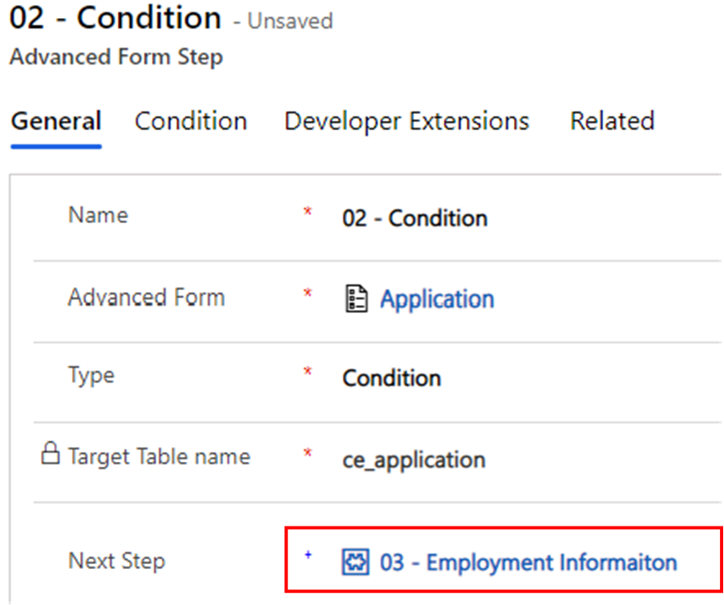

1. Navigate to the **Condition** tab and identify the **Next Step if Condition Fails** field. Leave it blank. This would be populated if we had another step after step 03.
2. Click **Save & Close**.
3. Navigate to the **General** tab on the Multistep Form record.
4. Populate **Start Step** with **01 – Personal Information**.



1. Click **Save & Close.**

## Part 4: Application Web Page

1. Navigate to the **Portals Management** model-driven application.
2. Navigate to **Web Pages** via the left navigation bar.
3. Open the **Apply Now** Web Page.
4. Populate **Multistep Form** with **Application**.

1. Click **Save & Close.**
2. Navigate to the Design Studio.
3. Click **Sync** in the top right corner, then select **Preview > Desktop**.

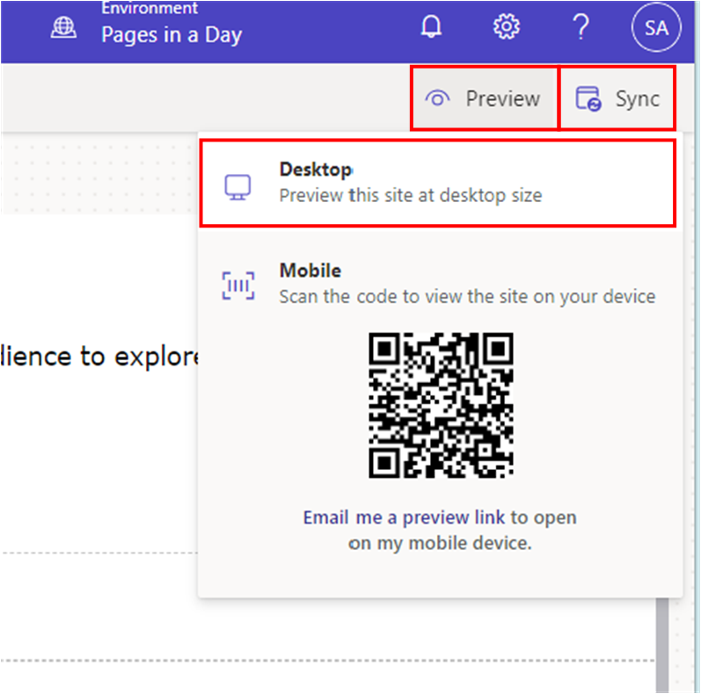

You should see the following on the Apply Now web page: 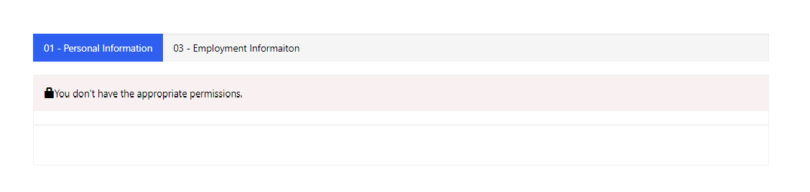

## Part 5: Page Permissions

1. Navigate back to the **Design Studio**.
2. Navigate to the **Apply Now** page and select the ellipses **(…)** next to the page name. Click on **Page settings**.

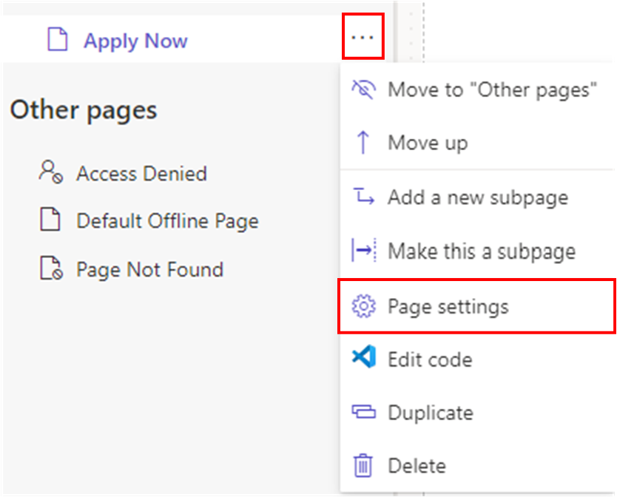

1. Navigate to the **Permissions** tab in the pop-up window.
   1. Notice that this page is publicly available to anyone on the web. That is why you could see the Apply Now page in the main navigation when you previously browsed your website. We will now lock this down so that only users signed in can access the page.
2. Select the radio button for **I want to choose who can see this page**.
3. Use the **Search roles** dropdown to select **Authenticated Users.**

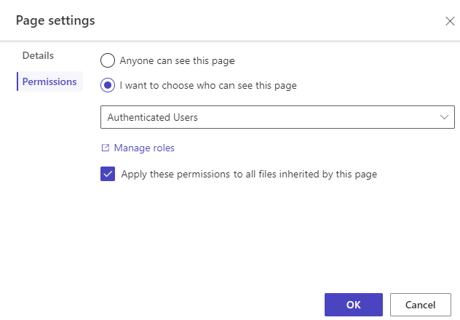

1. Click **OK.**
2. Click **Preview > Desktop** in the upper right corner. As you are not signed in, notice that Apply Now is no longer in the main navigation.



1. Sign into the site using Microsoft. Notice that the Apply Now page is available to you in the main navigation.



## Part 6: Table Permissions

1. Navigate to the **Set up** tab via the left navigation bar, then select **Table Permissions** beneath Security.

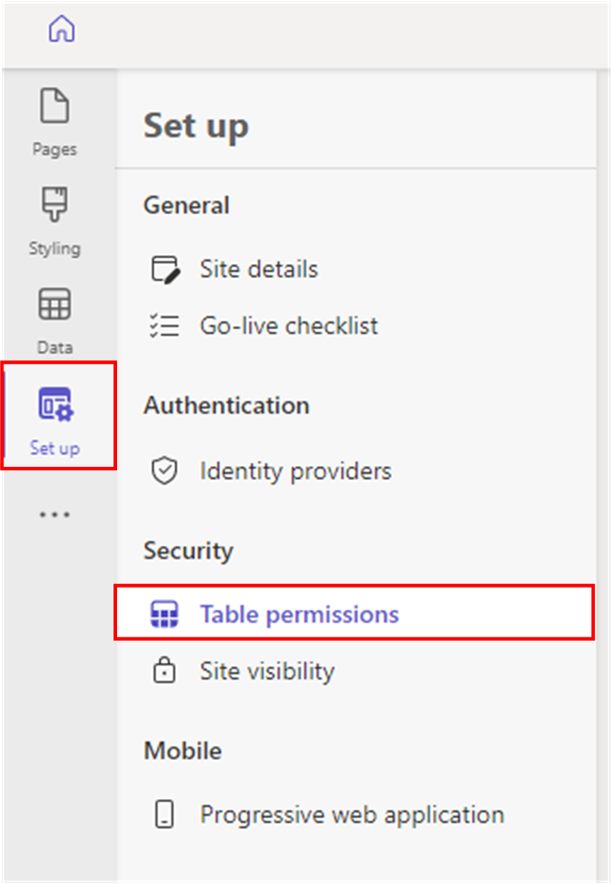

1. Click **+ New permission.**
2. Enter the following information:
   1. Name: Application – Authenticated Users
   2. Table: Application (ce_application)
   3. Access Type: Global access
   4. Permission to: Read, Write, Create, Append, Append to

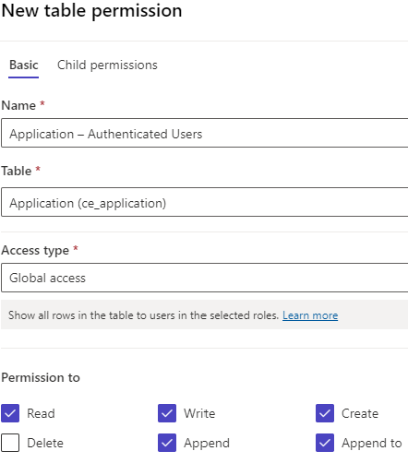

1. Click **+ Add roles** and select **Authenticated Users**.
2. Click **Save.**
3. Select **Sync** in the upper right corner, then select **Preview > Desktop**.
4. Login and navigate to the **Apply Now** page.
5. Click on the magnifying glass for the Job lookup field. Notice the error.

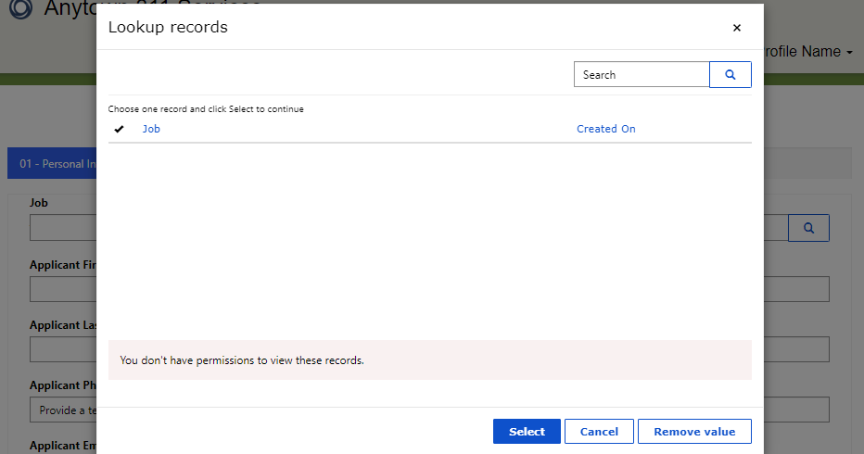

1. The above error is because we need to grant permission to this related table (Job).
2. Navigate back to **Design Studio.** Click on **+ New permission.**
3. Enter the following information:
   1. Name: Open Positions – Authenticated Users
   2. Table: Job (ce_job)
   3. Access type: Global access
   4. Permission to: Read, Write, Append, Append to

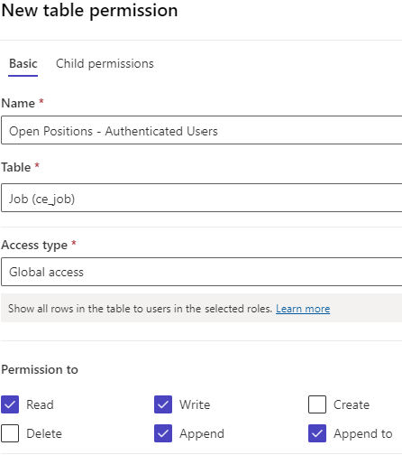

1. Click **+ Add roles** and select **Authenticated Users**.
2. Click **Save.**
3. Select **Sync** in the upper right corner, then select **Preview > Desktop**.
4. Login and navigate to the **Apply Now** page.
5. Click on the magnifying glass for the Job lookup field. The error has gone away, and you can now see the Job records you added in earlier labs.

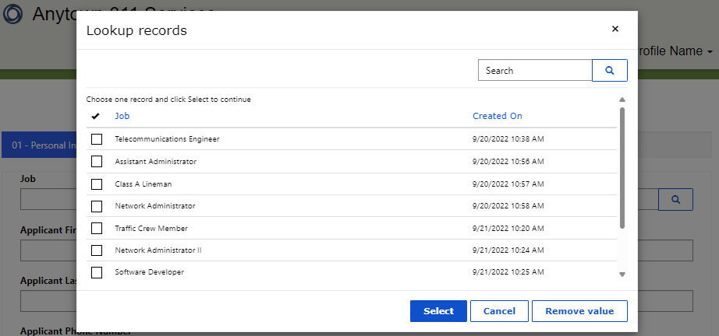

## Part 7: Testing Your Form

1. Fill out the form.
2. Test the false condition by keeping Currently Employed set to **no,** then click next.
3. Expected result:

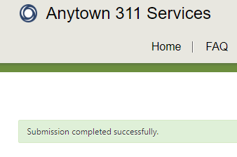

1. Navigate back to the Application form. Now, we must test the true condition. Fill out the form, set **Currently Employed** to **Yes,** and click **Next.**
2. Fill out the Employment Information, but do not submit.

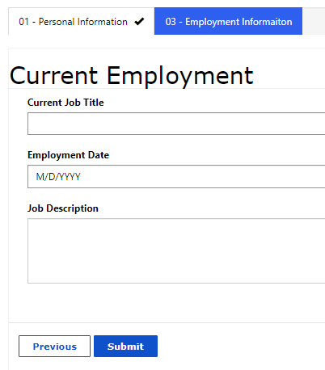

1. In another tab, navigate to **Portal Management.** Navigate to **Multistep Froms** > **Application**. Click on **the Sessions** tab to see the session that was just created.

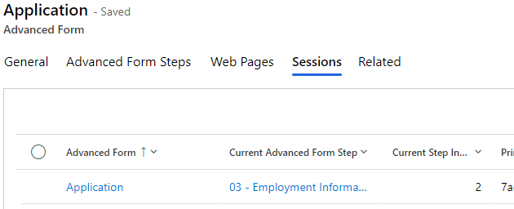

1. Navigate back to the tab with the website and click **Submit** once you complete the form.
2. Navigate to **Portal Management.**
3. Click **Refresh** at the top right of the sessions subgrid. Notice the session is no longer there, as it has been deactivated since the form has been successfully submitted.

You have completed Lab 4.